“Clinical narratives from Sheena’s Place”

Debbie Berlin-Romalis, BSW, MSW, RSW
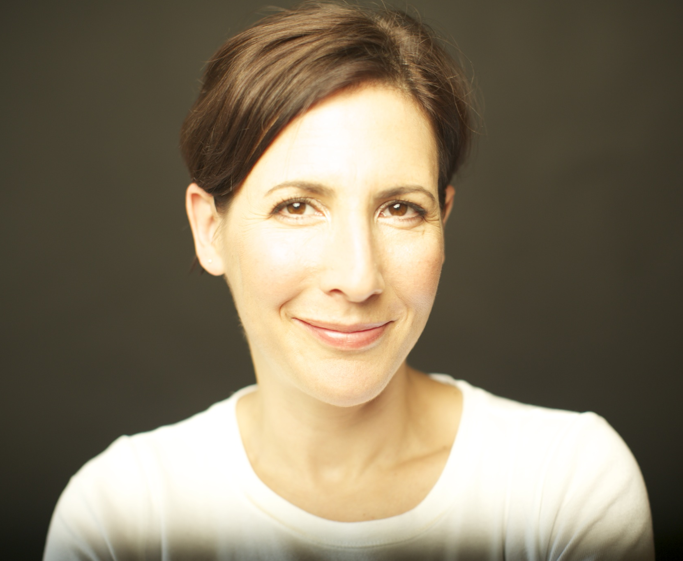
Social Worker/Psychotherapist
Executive Director of Sheena’s Place
Thursday, January 22nd, 2014
12:00 p.m. – 1:00 p.m. Eastern Standard Time

For almost 20 years, Debbie Berlin-Romalis has facilitated support groups at Sheena’s Place, a non-residential, non-institutional centre for individuals, families, and friends affected by eating disorders. Through her clinical work and observations, Debbie has developed “trademarked concepts” that illustrate and highlight specific phenomena related to the social determinants of health and the onset and development of eating disorders.

In this webinar, Debbie will deconstruct the following three concepts:

- Juicy Love, which describes the recipe for a healthy and resilient child and the consequences of not raising a child in a safe living environment.
- Busted Radar, which explains the neurobiological development adaptation in trauma survivors with a specific focus on “re-training” the brain.
- Crumb Theory, which reviews the “historical” psychology of women and its relationship with today’s women and girls “settling for less” in their personal and professional lives.

Debbie has been practicing as a Social Worker/Psychotherapist since 1991. She has done considerable agency work in various women’s shelters and community-based services. In addition to her private work, Debbie practiced clinical social work in the Division of Haematology/Oncology at The Hospital for Sick Children from 1998 to 2014, working with children and their families in the Stem Cell Transplant Program and the Paediatric Brain Tumour Program. She has facilitated groups for women with eating disorders and body image issues at Sheena’s Place since 1998. From 1998 to 2008, Deborah was a member of the Health Sciences Review Committee for Bioethics and Research at the Faculty of Medicine, University of Toronto. In 2003, she was appointed as an Adjunct Practice Lecturer at the Faculty of Social Work, University of Toronto. An active public speaker, she has presented at numerous conferences including TEDxToronto 2013.

TO REGISTER: Please go to https://tinyurl.com/nedicemails and join our Webinars and Events mailing list. Your membership gets you exclusive access to this and other webinars.

Space is limited – reserve your place today!
- This webinar is free of charge and open to the public. You will need a computer with a high-speed Internet connection and speakers (or a headset).
- If you would like to suggest a question for Debbie, please email it with your registration request.
- Can’t attend? Join our mailing list and you’ll receive the webinar slides and recording.

